Lab # Project 3 — Assessment Worksheet

**Course Name and Number: FRS301**

**Student Name: Tran Thanh Tuan**

**Student Id: SE161095**

**Instructor Name: Nguyen Van Vinh**

## **Identifying File Types**

***File 1***

1. **Opening by Notepad**

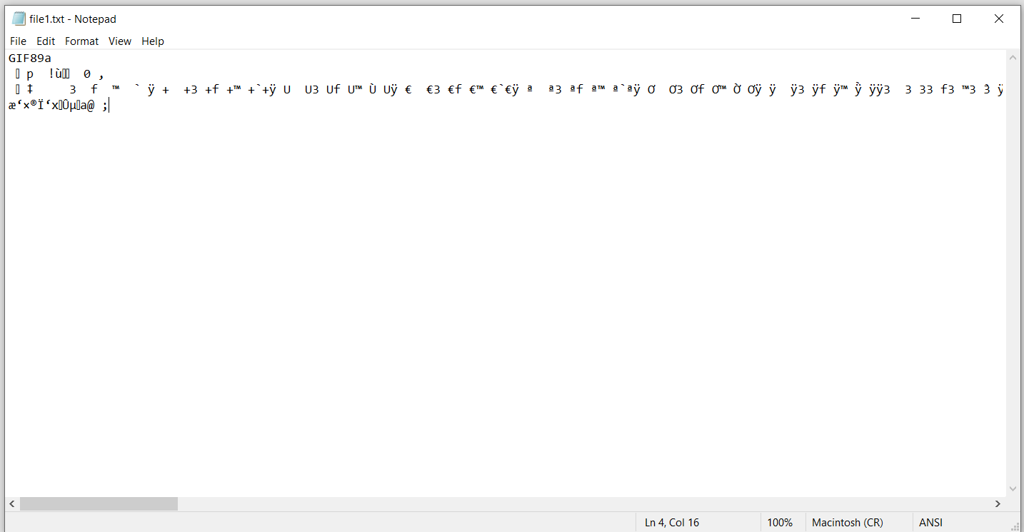

1. **Searching file type**



1. **Testing**



***File 2***

1. **Opening by Notepad**

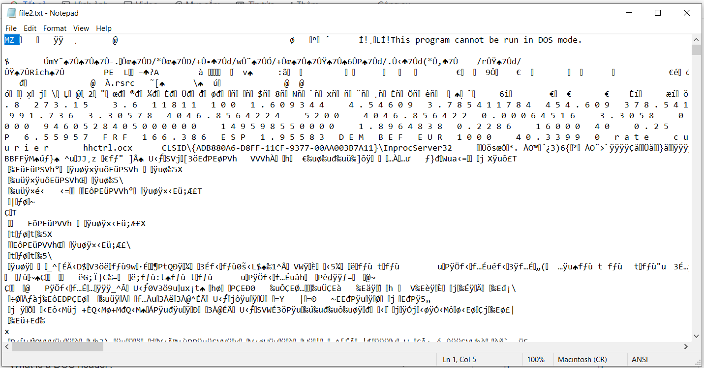

1. **Opening by Hex Editor**

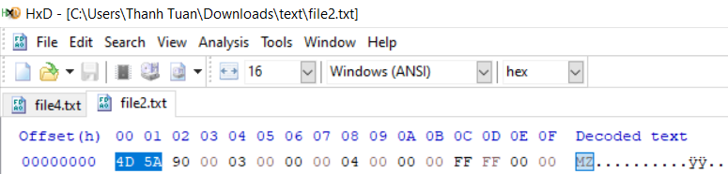

1. **Searching file type**

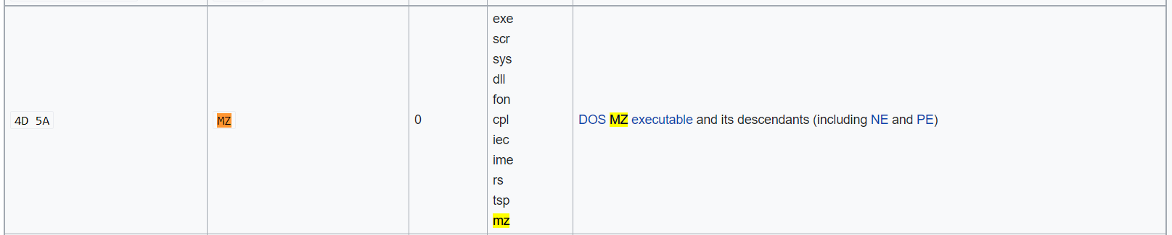

1. **Testing**

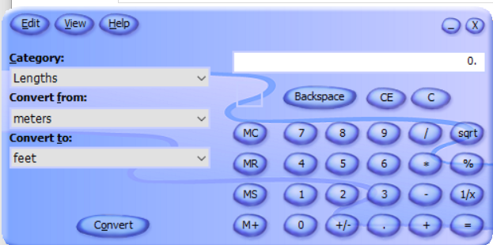

***File 3***

1. **Opening by Notepad**

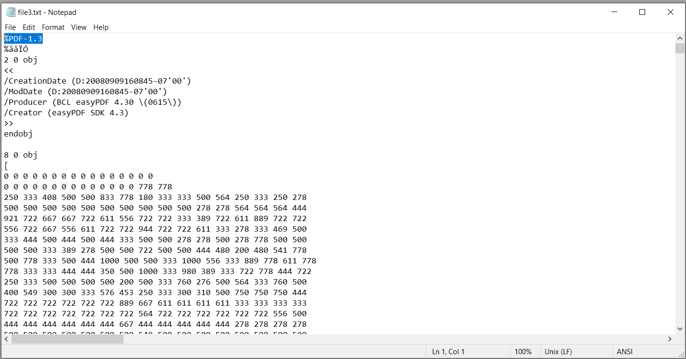

1. **Searching file type**



1. **Testing**

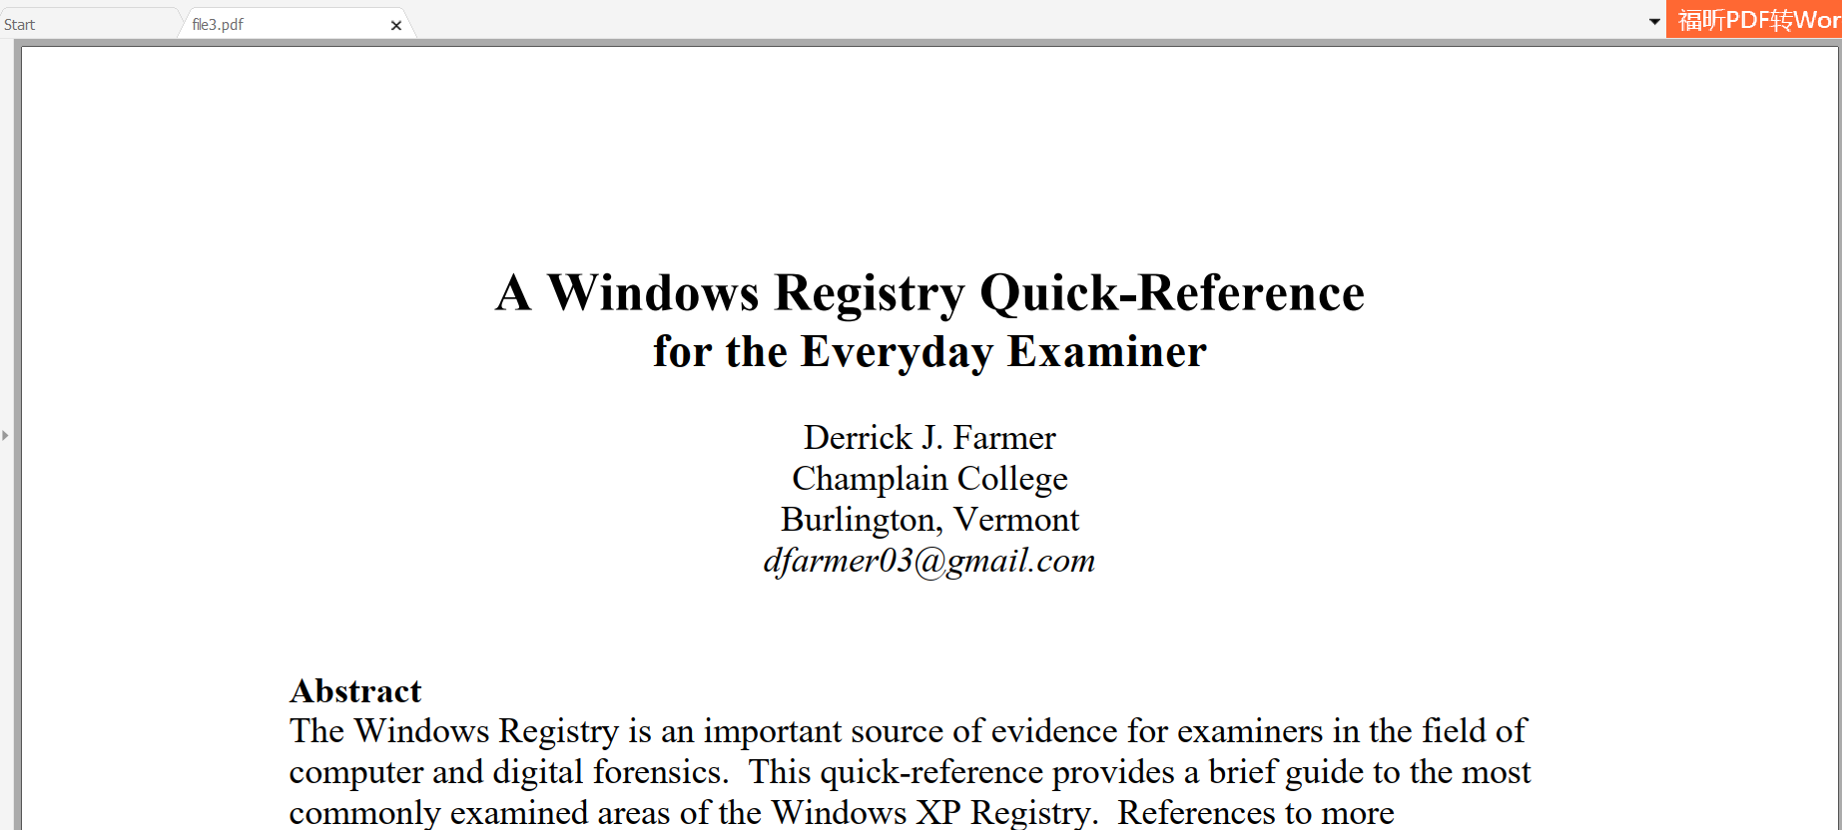

***File 4***

1. **Opening by Notepad**

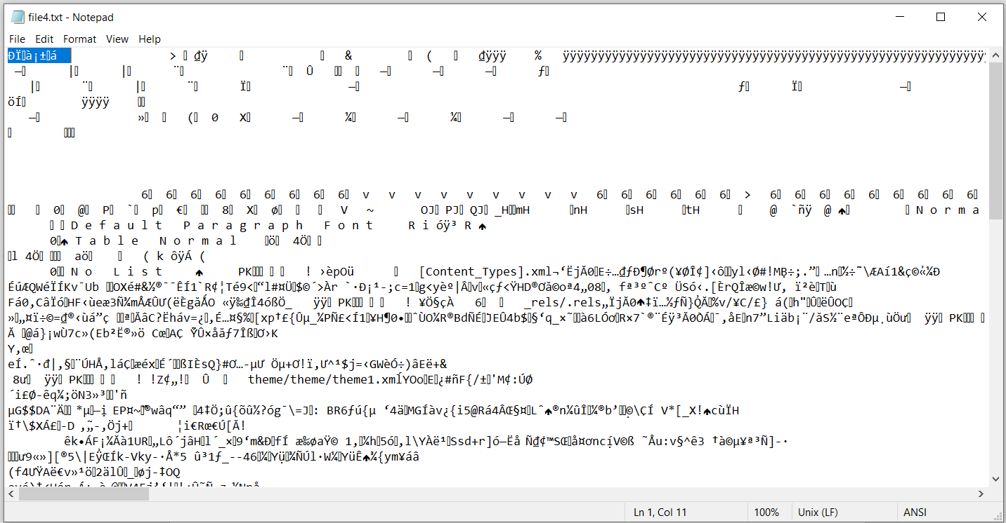

1. **Opening by Hex Editor**

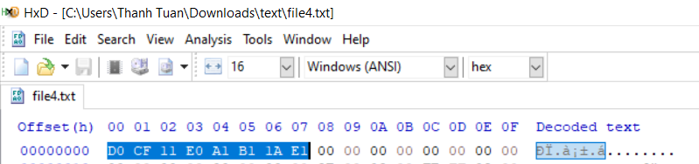

1. **Searching file type**



1. **Testing**

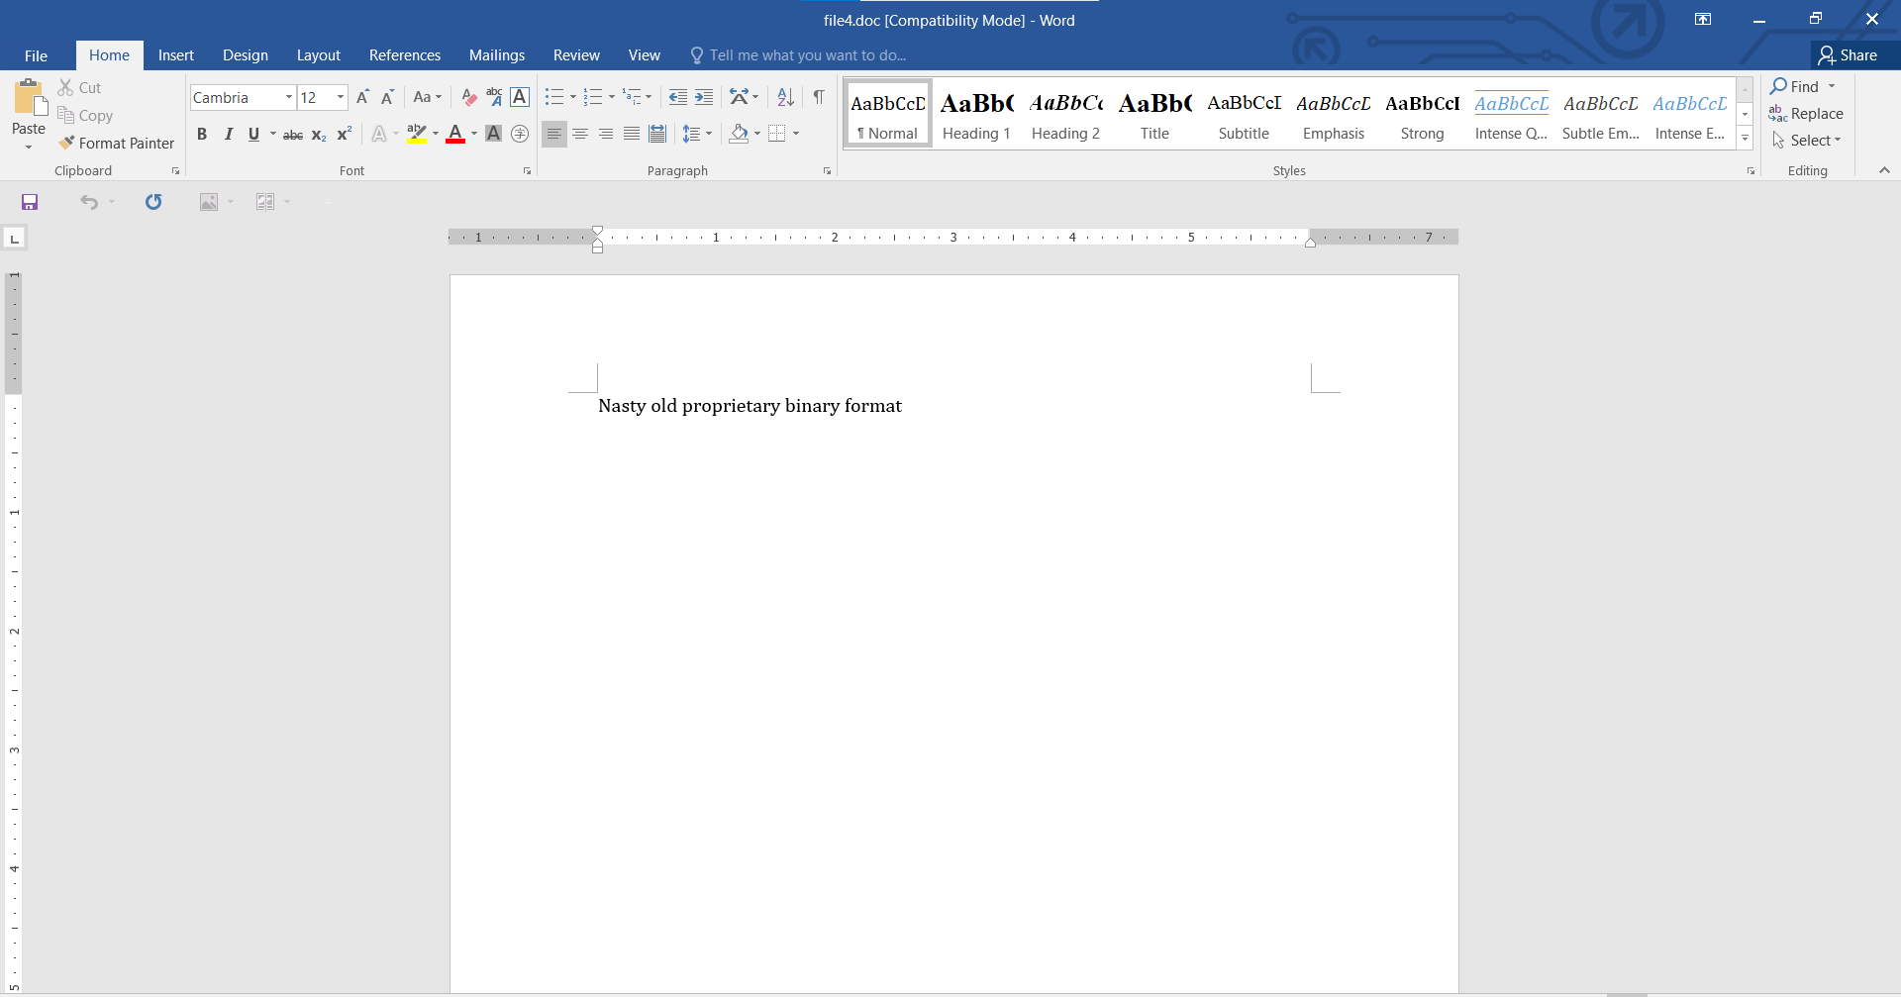

***File 5***

1. **Opening by Notepad**

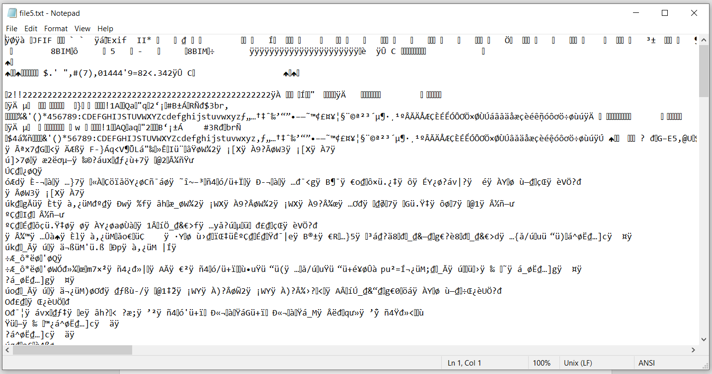

1. **Opening by Hex Editor**

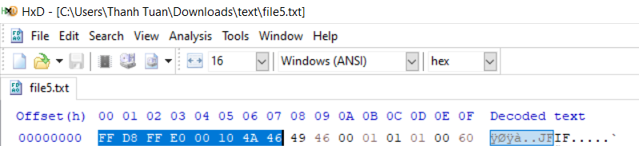

1. **Searching file type**

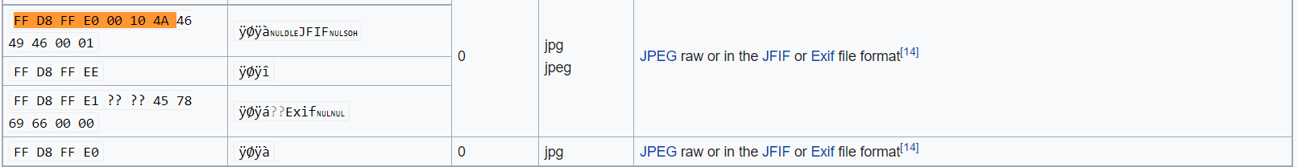

1. **Testing**



